Step 1: Login to Concur and click on “Profile”, and click on “Profile Settings”.
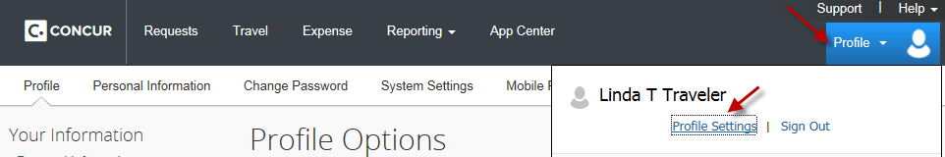
Step 2: On the menu, select “Expense Preference”.
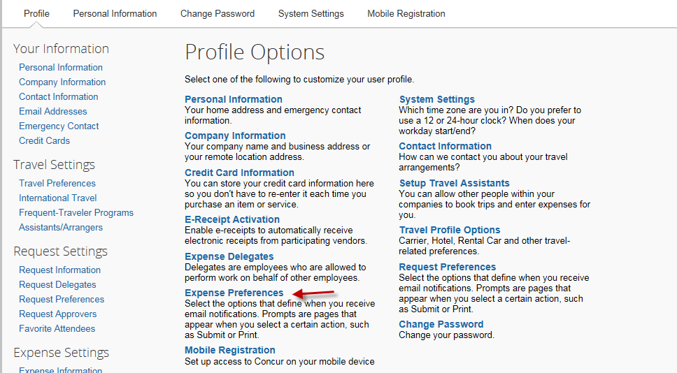
Step 3: Select the options to define when you want to receive e-mail notifications. Click on “Save”.
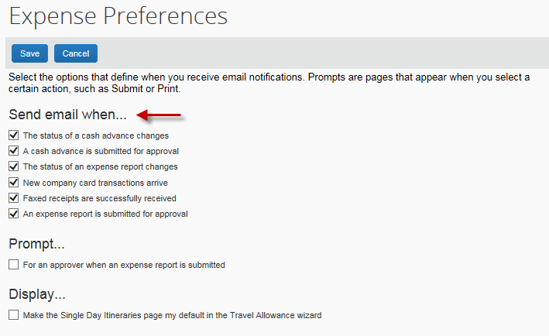

Step 4: Go back to the menu – Profile Options. Then, select “System Setting” this time.
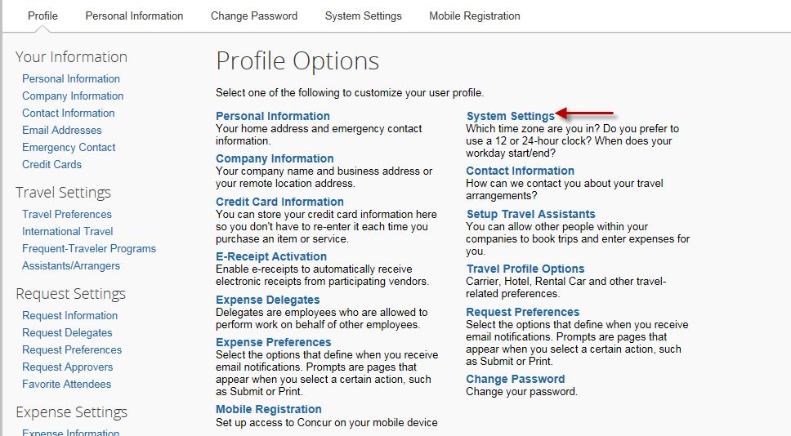

Step 5: Go to the Email Notifications section and select appropriate boxes. Click on “Save”.
